2nd problem Screen shots

1. In case of + sign

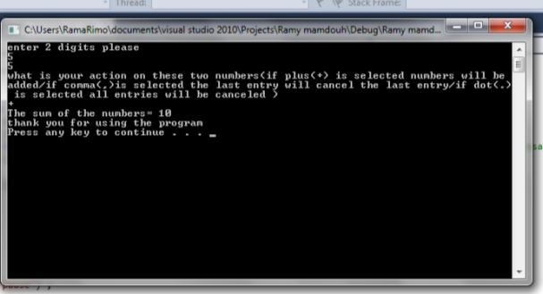

2. In case of comma sign(1)

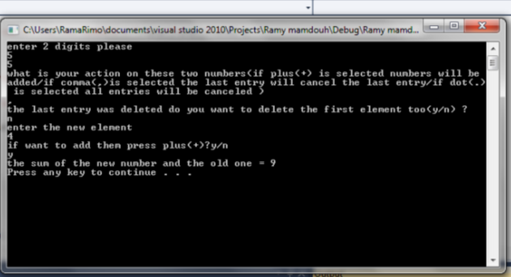

3. In case of comma sign(2)

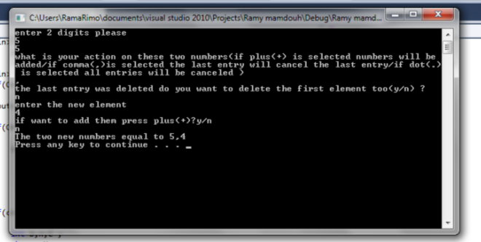

4.in case of comma sign (3)

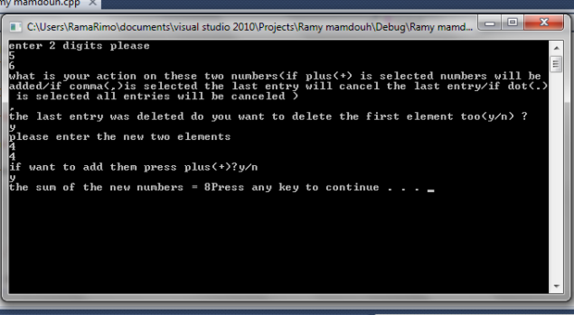

5.in case of comma sign(4)

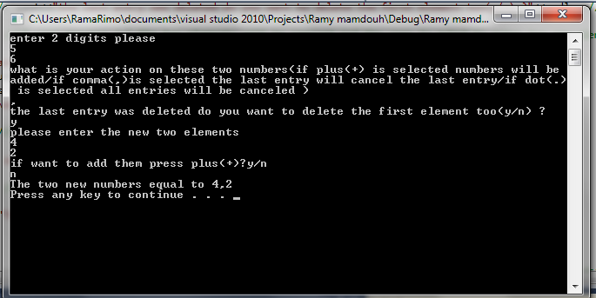

6. Incase of dot sign(1)

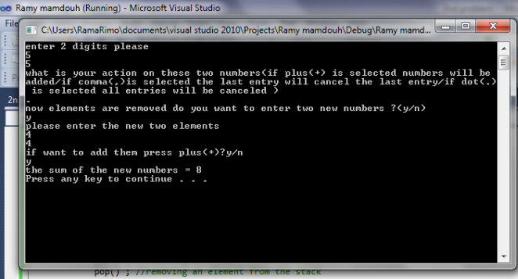

7.Incase of dot sign(2)

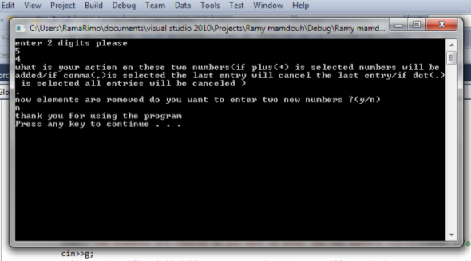

8.In case of dot sign (3)

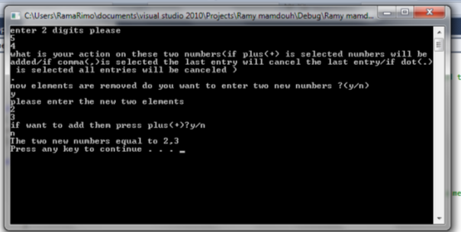

Code:

#include<iostream>

#include<string>

using namespace std ;

int const size = 5; //size of the stack= 5

int thestack[size] ;//initialization of the stack

int top= -1 ;

bool isfull() //checking if the stack is full

{

if(top==size-1)

{ return true ;

}

return false ;

}

bool isempty() //checking if the stack is empty

{

if(top==-1)

{

return false ;

}

return true ;

}

int pop() //removing one element from the stack

{

return thestack[top--] ;

}

void push (int element )//putting one element in the stack

{

if(!isfull())

{

thestack[++top]=element ;

}

}

void main()

{

int x,y ;

char c ;

cout<<"enter 2 digits please "<<endl ;

cin>>x;

cin>>y ;

push(x) ; //putting x in the stack

push(y) ; //putting y in the stack

cout<<"what is your action on these two numbers(if plus(+) is selected numbers will be added/if comma(,)is selected the last entry will cancel the last entry/if dot(.) is selected all entries will be canceled )"<<endl ; //asking the user what action he wants to do

cin>>c ;

if(c=='+')//if user enters + the two elements will be added

{

cout<<"The sum of the numbers= "<<pop()+pop()<<endl ;

cout<<"thank you for using the program"<<endl ;

}

// if the user enters , the last element will be deleted

if(c==',')

{

int c,d,t;

char q,P,O ;

pop() ;

/\*line b \*/ cout<<"the last entry was deleted do you want to delete the first element too(y/n) ?"<<endl ; //asking the user if he wants to delete the first element too

cin>>q ;

if(q=='y') //if user answers 'y' the two elements will be removed and the user is asked to enter two new element

{pop();

cout<<"please enter the new two elements "<<endl ;

cin>>c ; push(c);

cin>>d; push(d) ;

cout<<"if want to add them press plus(+)?y/n "<<endl ;//if the user wants to add the two new numbers

cin>>P ;

if(P=='y')//if the user answers 'y' the sum will be shown

{

cout<<"the sum of the new numbers = "<<pop()+pop() ;

}

if(P=='n') //if the users answers 'n' the two numbers will be shown

{

cout<<"The two new numbers equal to "<<pop()<<"/t"<<pop() <<endl ;

}

}

if(q=='n') //if the user after the question in line b entered no he will be asked to enter a new element and if he wants to add them

{cout<<"enter the new element "<<endl ;

cin>>t;

push(t);

cout<<"if want to add them press plus(+)?y/n "<<endl ;//asking the user if he wants to add them

cin>>O ;

if(O=='y')

{

cout<<"the sum of the new number and the old one = "<<pop()+pop()<<endl ;

}

if(O=='n')//if answer = n the program will display thank you for using program

{

cout<<"thank you for using the program"<<endl ;

}

}

}

if(c=='.')// and finally if the comma is written the stack will be empty

{

int b,n,C ;

char g,M ;

pop() ; //removing an element from the stack

pop() ; //removing an element from the stack

cout<<"now elements are removed do you want to enter two new numbers ?(y/n)"<<endl ;//asking the user if he wants to enter to new elements to the stack

cin>>g;

/\*line c \*/ if(g=='y') //if the answer = 'y' the user will be asked to enter two numbers and they will be pushed into the stack

{

cout<<"please enter the new two elements "<<endl ;

cin>>b ; push(b);

cin>>n; push(n) ;

cout<<"if want to add them press plus(+)?y/n "<<endl ;//the user is asked if he wants to add the two new elements

cin>>M;

if(M=='y')

{

cout<<"the sum of the new numbers = "<<pop()+pop()<<endl ;

}

else

cout<<"thank you for using the program "<<endl;

}

if(g=='n')// related to line c if the user from the first entered 'n' he will display only a message

{

cout<<"thank you for using the program"<<endl ;

}

}

system("pause") ;

}